# Installing XAMPP and HeidiSQL

This document is a walkthrough of the process of **installing and configuring XAMPP and HeidiSQL**

This lab is part of the ["Programming Fundamentals" course @ SoftUni](https://softuni.bg/trainings/3835/programming-fundamentals-september-2022).

**XAMPP** is a completely free, easy to install Apache distribution containing MariaDB, PHP, and Perl. The XAMPP open-source package has been set up to be incredibly easy to install and use.

# Installing XAMPP and Configuring MySQL Database

This first part will show you how to **install XAMPP** and **create your first MySQL DB**.

## Downloading XAMPP

Download XAMPP from <https://www.apachefriends.org/download.html>.

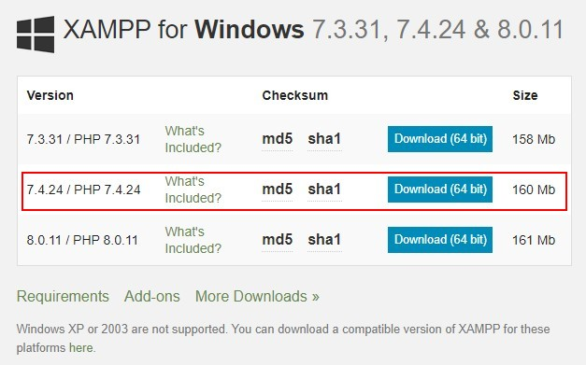

## Installing XAMPP

The pictures below will show you the steps you need to go through to install **XAMPP** successfully.

Install XAMPP in the **default directory** ("C:\xampp"), or you might encounter permission troubles later on.

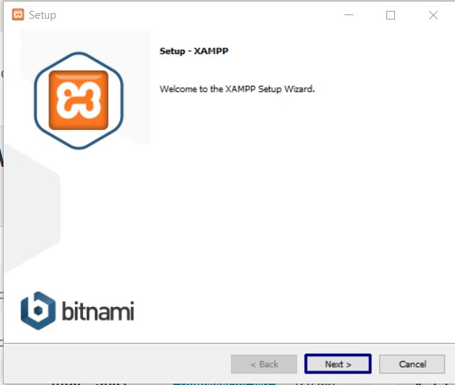

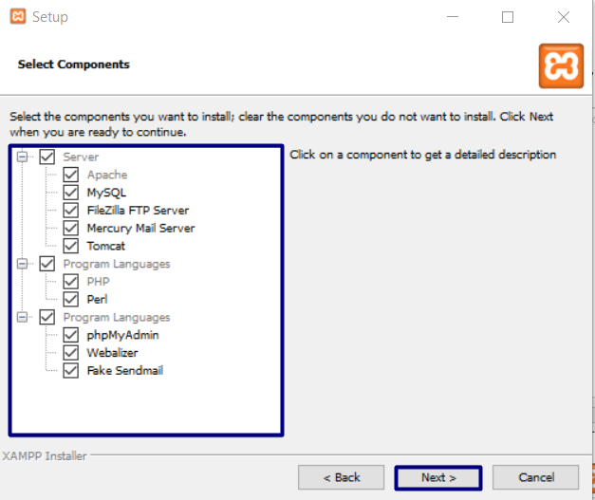

If you are not in the **PHP Track**, you can select only MySQL:

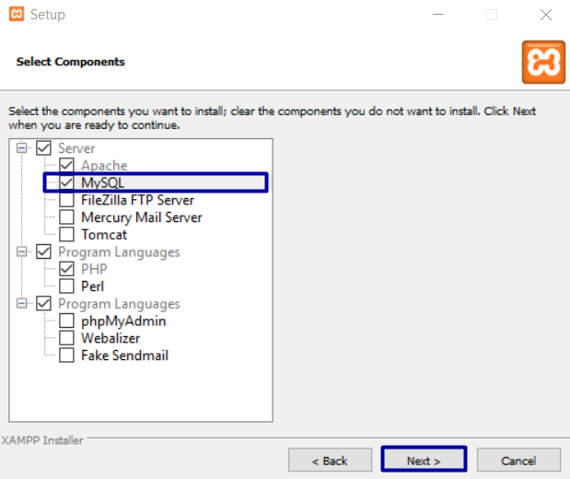

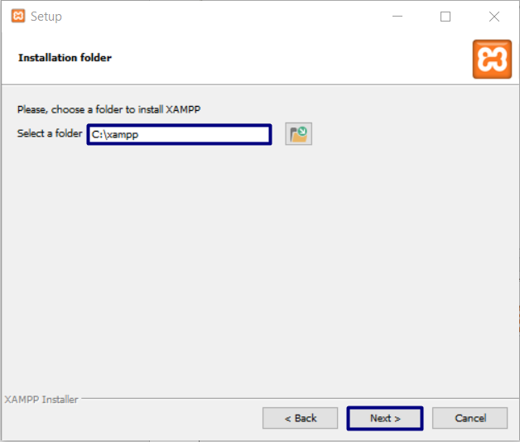

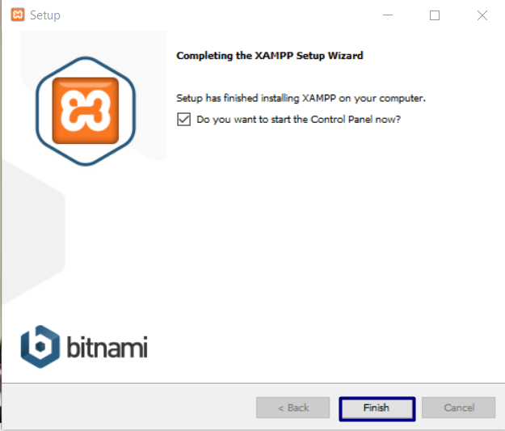

## XAMPP First Start

The first time you **start XAMPP**, you will get a **language selection screen** like this one:

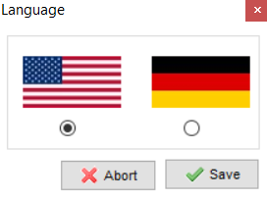

After you choose the language you prefer, you will see the **main screen of XAMPP**:

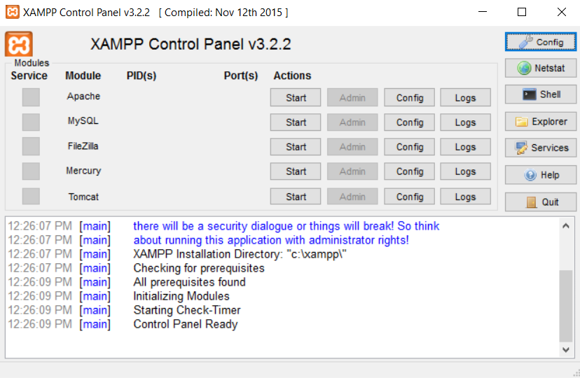

## Start MySql Database

Now we need to **start MySql Database**:

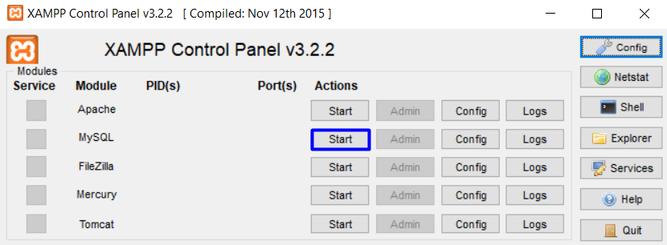

If everything is correct, the **MySql** label will become green, and you will see the default **port** - **3306**.

# Installing HeidiSQL

Before you start, you can download [HeidiSQL](https://www.heidisql.com/) from [here](https://www.heidisql.com/download.php). "**Heidi**" allows you to see and edit data and structures from databases. You can install the **tool** by clicking next, next, next…

When you open **Heidi,** you are going to see this:

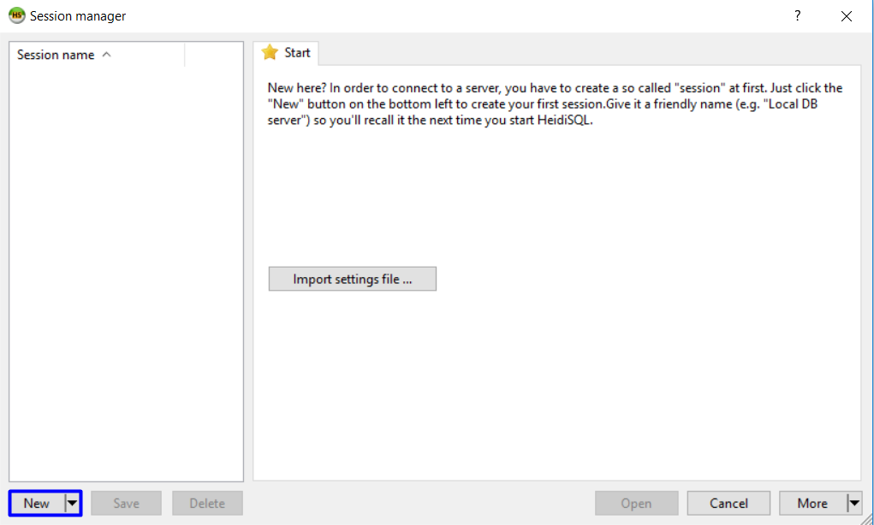

You can create a new session (click on "New") and open it. Then you can manage your databases:

